04 | Improved Product / MVP
  - Part 2 — Implemented improvements and demonstration evidence
PROJECT SafeStep | Deliverable 4 | 11 November 2026
TEAM Zhumabay Dias · Temirlan Satybaldy · Beknur Ualikhanuly · Sagidolla Beibars · Saparbek Bekzat
STATUS / SCOPE: This is an EVIDENCE DOCUMENT, not the executable product. The team must also supply/show the working SafeStep repository and live local demonstration.

1. Existing product and improvement objective
SafeStep is an academic fraud-prevention MVP with risk scoring, automatic holds, simulated step-up verification, contact-centre decisions, audit export and a local incident outbox. Part 2 selected two issues from the baseline: ISS-06 (automatic audit reasons) and ISS-04 (warning fetch with no recovery). Both were modified in the actual application rather than in a static mockup.

2. Improvement A — Explicit operator decision reason
Before | After | Verification
Operator reason optional; empty text silently replaced by predefined confirmation/fraud statement. | Release and cancel require a non-whitespace reason in UI and API. Blank payload rejected with HTTP 422. | 8 additional backend cases; manual before/after decision and audit screenshots. Source: HoldDecisionForm.tsx, schemas.py, dictionaries.ts, test_flows.py.

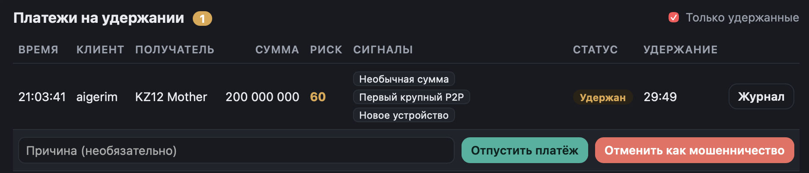
Figure 1. Before: operator reason was labeled optional.
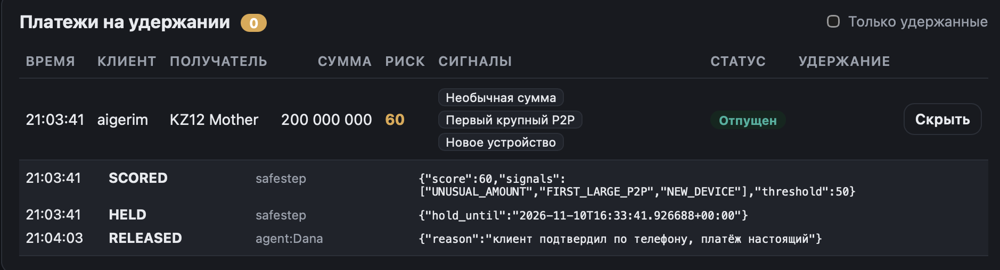
Figure 2. Before: audit contained a predefined statement after blank-reason handling. The original screenshot and reviewed sequence support the explanation; it should not be mislabeled as the same transaction as Figure 1 without further evidence.
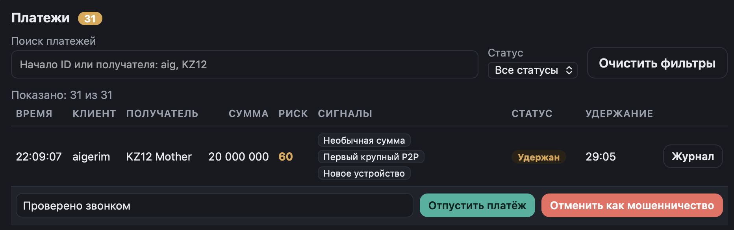
Figure 3. After: the operator entered the reason “Проверено звонком” before releasing the held payment.
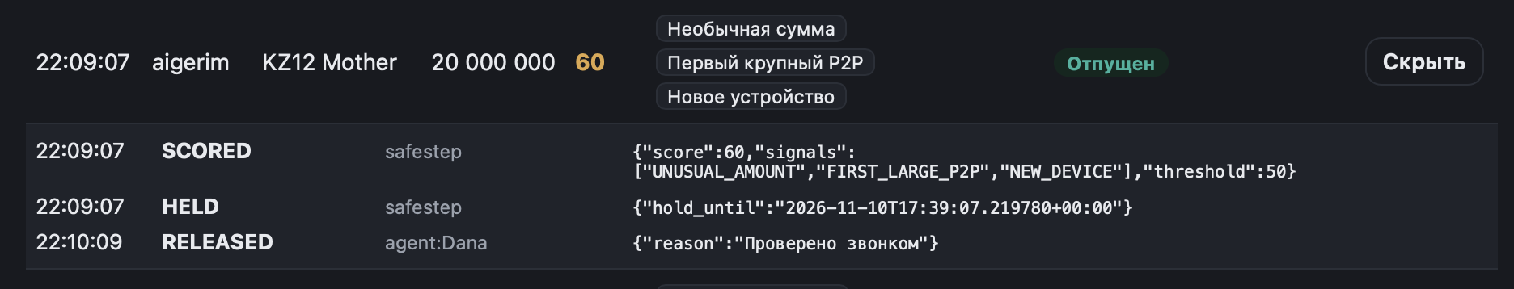
Figure 4. After: payment RELEASED and audit persisted the operator-entered reason. This does not prove an actual phone call took place.

3. Improvement B — Warning error and Retry
Before: a failed warning request had no rejection handler and could leave previous warning text visible. After: a localized error and Retry control were added; retry issues another warning GET request, and stale-result guards prevent older request results from replacing newer ones. User-supplied manual evidence in the earlier review showed an error state and recovery after restarting the backend.
The 3.13-second “Screen Recording 2026-11-10 at 21.19.09.mov” shows the earlier warning text not changing when language buttons are pressed. The recording alone does not prove whether the backend was down. The earlier submitted “Bad Gateway” screenshot concerned a payment-action failure and is not valid evidence of warning loading failure.
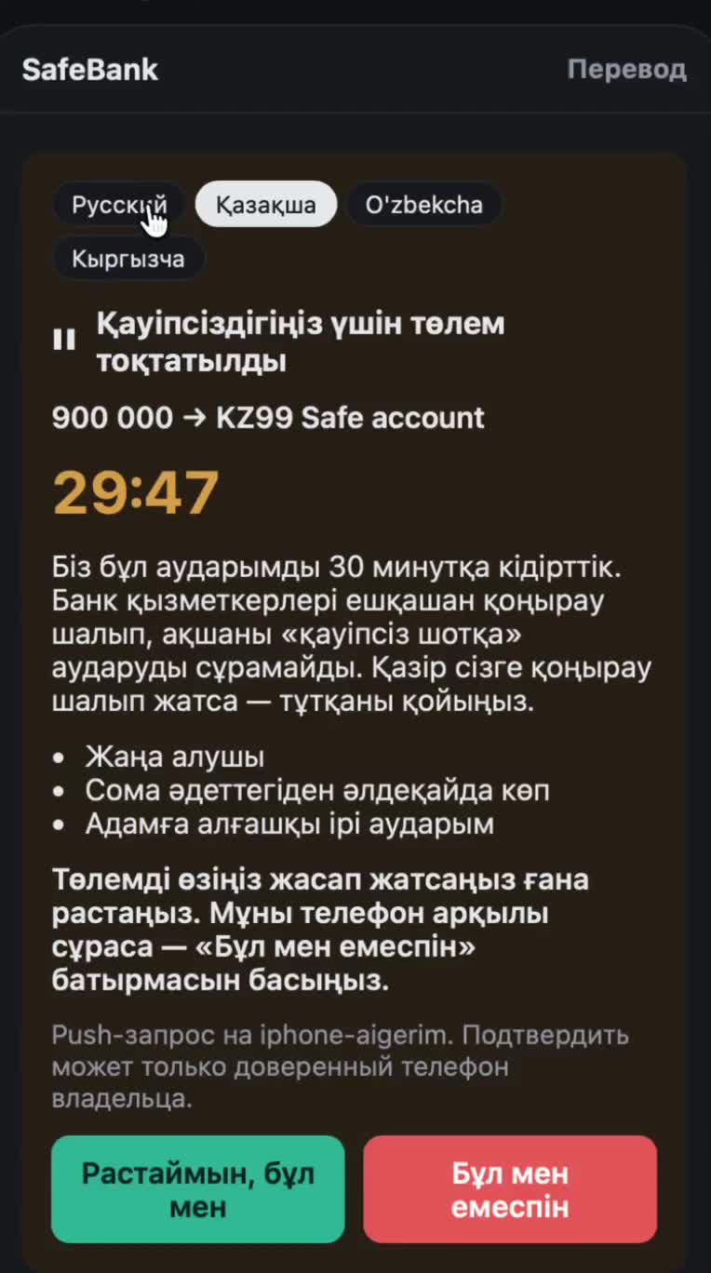
Figure 5. Still from the earlier warning-behaviour recording; accompanying video is included with the submission evidence.

4. Code files and validation
Area | Affected file | Verified change
Frontend decision | frontend/src/features/hold-decision/ui/HoldDecisionForm.tsx | Require a typed reason; remove fallback.
Backend validation | backend/app/presentation/api/schemas.py | Reject blank/whitespace reason.
Warning UI | frontend/src/widgets/hold-screen/ui/HoldScreen.tsx | Error state; Retry; stale-request guard.
Localization | frontend/src/shared/i18n/dictionaries.ts | Russian/Kazakh label and error text.
Backend tests | backend/tests/test_flows.py | Eight new reason-validation cases.

Check | Result
Backend suite after Part 2 | 18 passed, 1 warning (owner-executed).
Frontend build / lint | Passed after updates.
Manual UI | Blank reason rejected; warning error and recovery demonstrated.

5. Remaining handover evidence
Attach the actual updated repository/commit or show the running local application during defense. Error and recovery screenshots were described in the Part 2 review but their original image bytes are not among the current uploaded evidence used for this pack; if separately available, attach them to the ClickUp P2-03 card. Do not substitute this written report for the application itself.

